*Vietnamese National University HCMC*

*International University*

*School of Computer Science and Engineering*

Final Project Proposal

*Topic 7 - Weather forecasting system*

Member:

Pham Dong Quan – ITDSIU19015

Vu Xuan Linh – ITDSIU19008

Nguyen Huynh Thuy Tien – ITDSIU19056

Le Trieu Long – ITDSIU19044

Le Thanh Phuong Nam – ITITUN19008

*Instructor:* Assoc. Prof. Nguyen Thi Thuy Loan

TABLE OF CONTENT

1. INTRODUCTION 3
2. MEMBERS & CONTRIBUTION 4
3. RELATIONAL MODEL 5
4. APPLICATION 6
5. DEMONSTRATION 6
6. CONCLUSION, LIMITATION & DISCUSSION 9
7. REFERENCES 9
8. **INTRODUCTION**

This project is a system that use a combination of science and technology for making accurate predictions on weather conditions of a particular location at a particular time based on multiple parameters, such as temperature, humidity, wind speed, etc.

The system has an administrator login to update the database to provide more accurate prediction. The predictions made by the systems will based on historical data stored in the database.

The project is an application having:

* A graphical user interface where users can login via ID and password or register (if have not had an ID yet) by filling registration form.
* User will manually enter the current parameters of the location, then the system will predict the weather conditions of that location.

***GitHub:*** <https://github.com/trieulongben/forecastWeather>

1. **MEMBERS**

|  |  |  |
| --- | --- | --- |
| **NAME** | **STUDENT ID** | **ROLE** |
| Phạm Đông Quân | ITDSIU19015 | Leader |
| Vũ Xuân Linh | ITDSIU19008 | Member |
| Nguyễn Huỳnh Thuỷ Tiên | ITDSIU19056 | Member |
| Lê Triệu Long | ITDSIU19044 | Member |
| Lê Thanh Phương Nam | ITITUN19008 | Member |

Work contribution:

|  |  |  |
| --- | --- | --- |
| **WORK** | **DURATION** | **ASSIGNED MEMBERS** |
| Collecting data | 3 days | Tiên, Linh, Nam |
| Implementing model | 1 week | Tiên, Linh, Nam |
| Creating ER Diagram | 3 days | All members |
| Creating database | 4 days | All members |
| Administrator ID | 3 days | Quân |
| Implementing user UI | 4 weeks | Quân, Long |
| Self-evaluating project | 3 days | Long, Nam |

1. **RELATIONAL MODEL**

ERD conceptual schema:

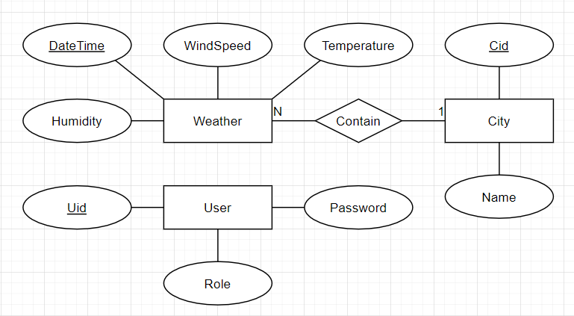

Relational database schema:

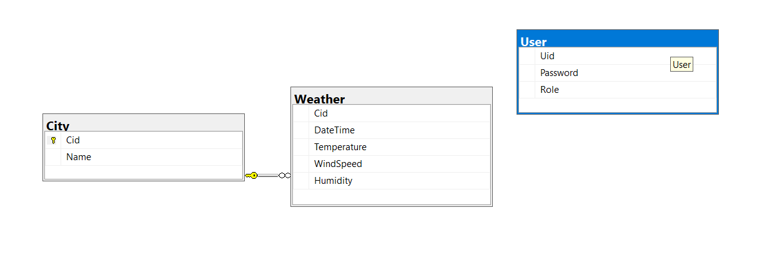

1. **APPLICATION**

There are two types of users: Administrator and User.

Features for Administrator:

* Add/Update new city (if there are data for that city).
* Update weather data for City.

Feature for User:

* Search/View forecasted weather for location input.
* View historical data of location input.

1. **DEMOSTRATION**

First, the Login Page will appear. There is a default User with password user for guest user, or user can register if wanted.

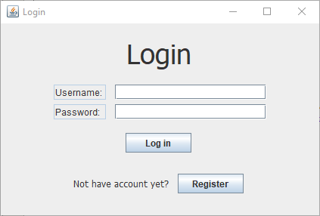

Login Page

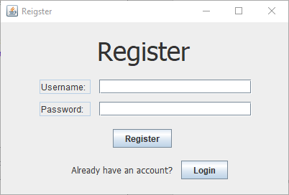

Register Page

After successfully logging in, user will be direct to UserInput screen, while Admin will be shown Update Screen.

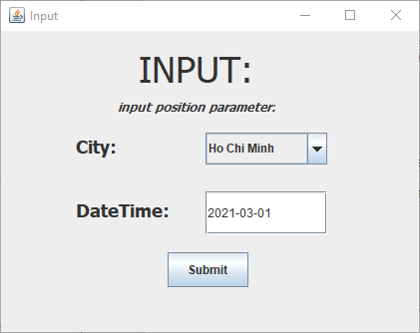

Input Screen

User can choose city (Da Nang, Hue, Ha Noi and Ho Chi Minh) and date (currently between 01/03/2021 and 04/05/2021) to view data. The result page will contain average data of the date given.

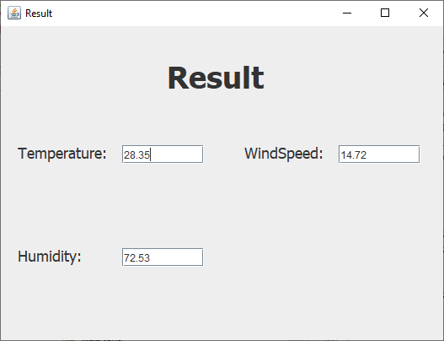

Administrator can update data of a city by providing temperature, humidity and wind speed of the city in a specific datetime.

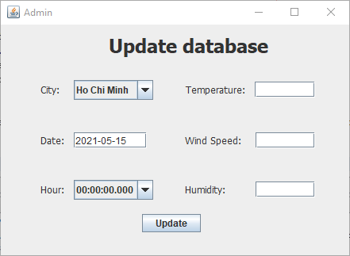

1. **CONCLUSION, LIMITATION & DISCUSSION**

This is a small prototype of a weather forecast application. The limitation is that the model is not a model that is used by professional weather forecaster, and the data lacks consistency.

Moreover, the weather forecast model relies only on past data to provide prediction. Therefore, if there are any incorrection in the initial data, the prediction will not be accurate.

Such application, if built with professional expertise, can be highly useful for people and organizations to reduce weather-related losses and enhance societal benefits, including protection of life and property, public health and safety, and support of economic prosperity and quality of life.

1. **REFERENCES**

* Forecast Model:

<http://www.ux1.eiu.edu/~cfjps/1400/forecasting.html>

<https://www.ijert.org/research/weather-forecasting-models-methods-and-applications-IJERTV2IS120198.pdf>

* Past weather data

[https://en.tutiempo.net/vietnam/](https://en.tutiempo.net/vietnam/ho-chi-minh.html?data=last-24-hours)

<https://www.timeanddate.com/weather/vietnam/>

<https://www.meteoblue.com/en/weather/archive/>